## Assignment 4

1.List all customers and the products they ordered with the order date.(Inner join)

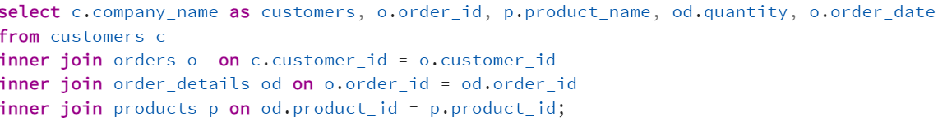

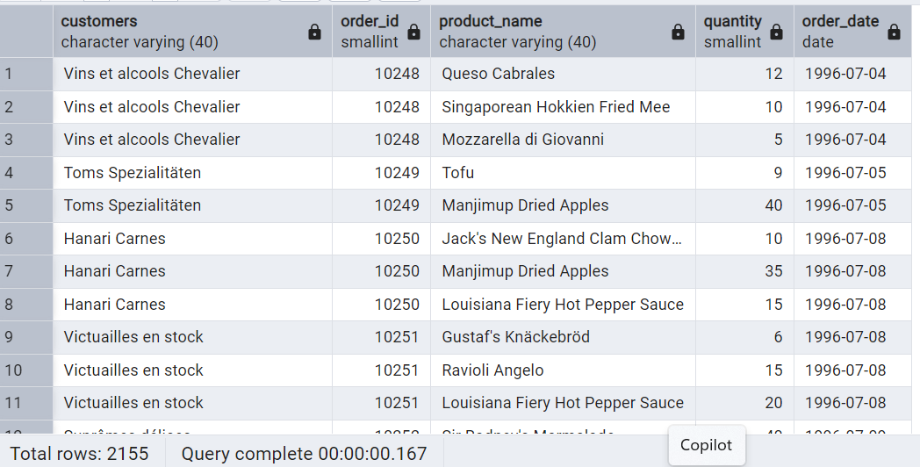

2.Show each order with customer, employee, shipper, and product info — even if some parts are missing. (Left Join)

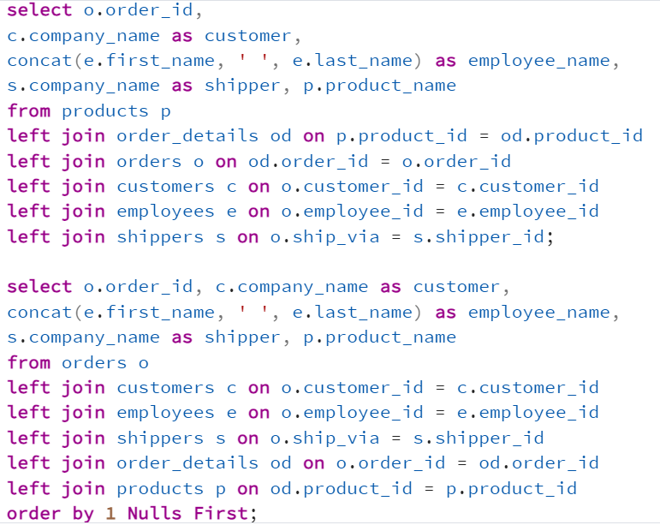

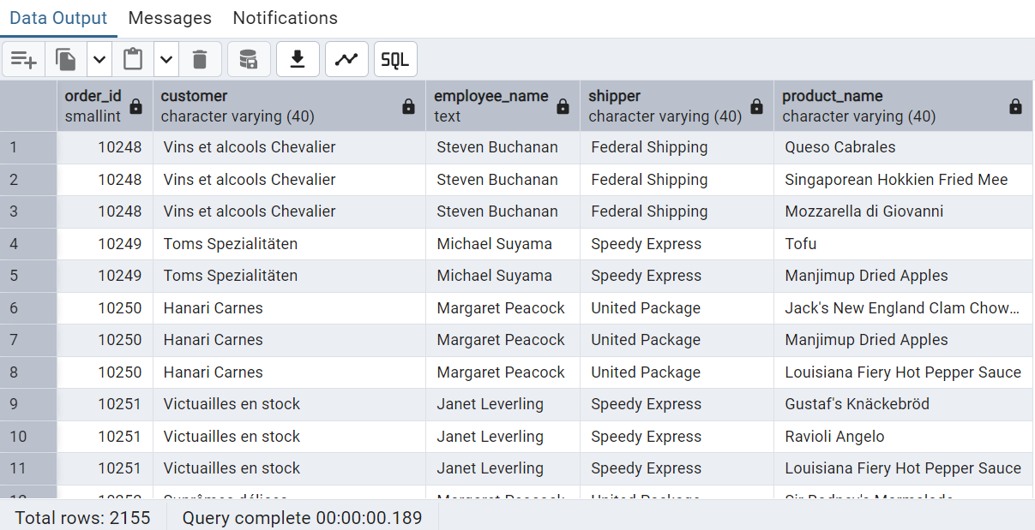

3.Show all order details and products (include all products even if they were never ordered). (Right Join)

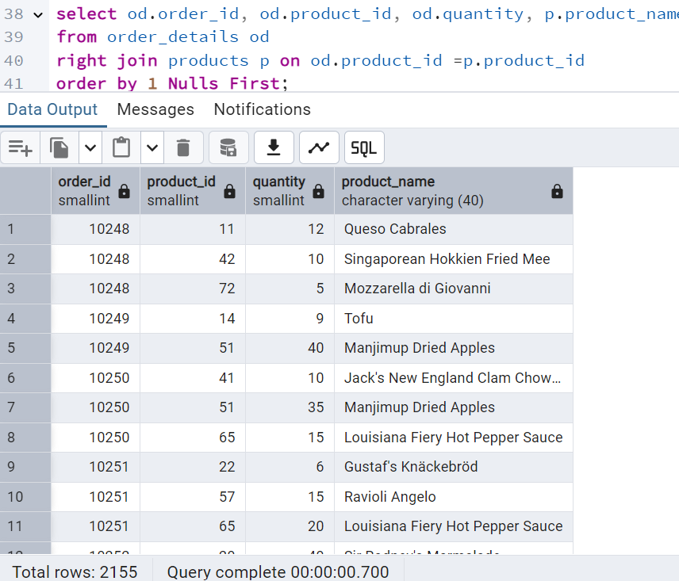

4.List all product categories and their products including categories that have no products,

and products that are not assigned to any category. (Outer Join)

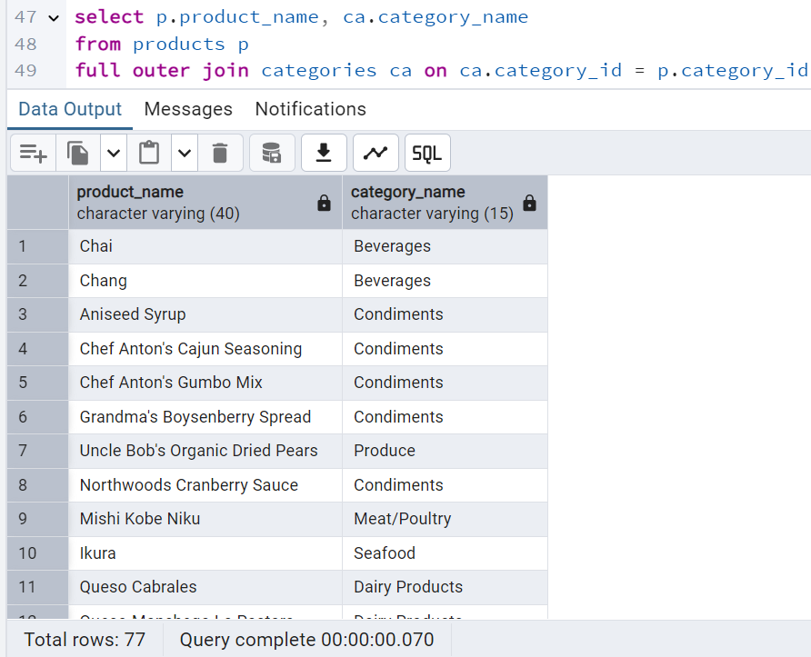

5.Show all possible product and category combinations (Cross join).

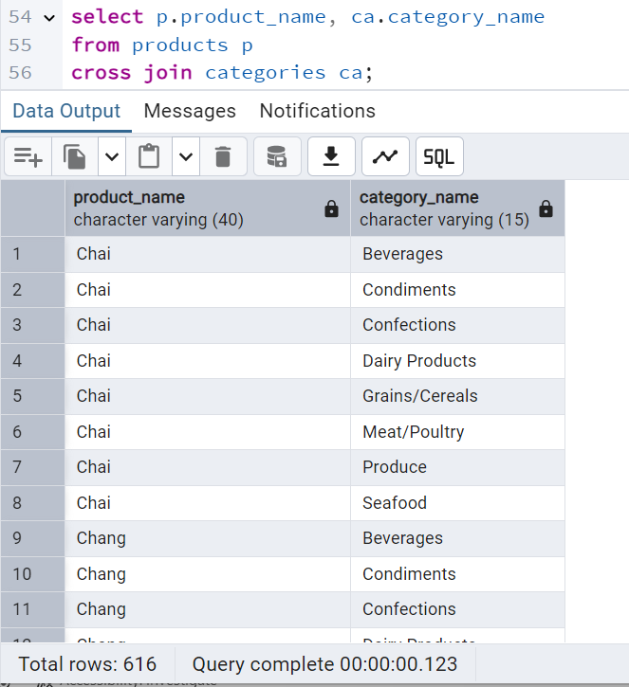

6.Show all employees who have the same manager(Self join).

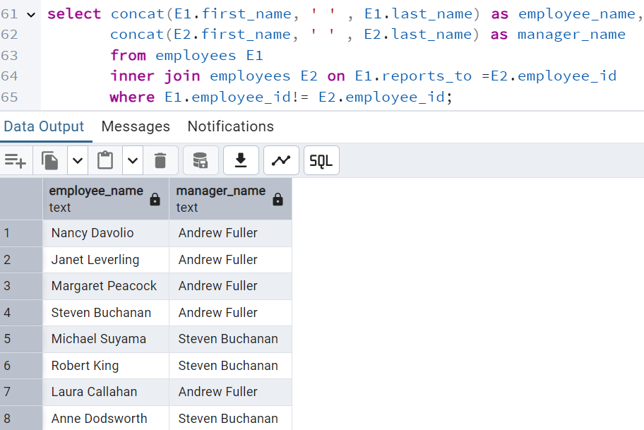

7.List all customers who have not selected a shipping method.

